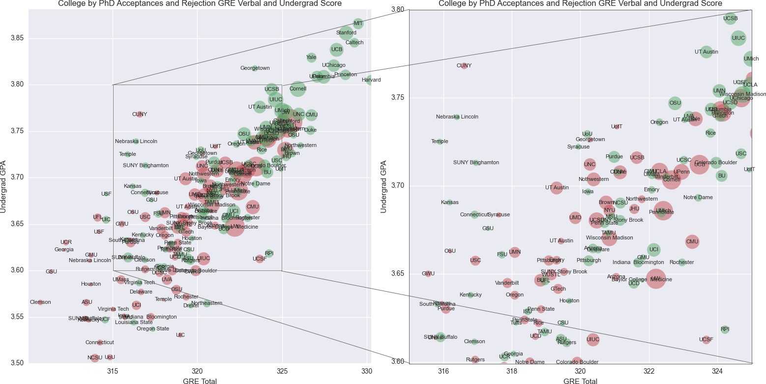

1. It is using bars with the dots to represent average score in different school. This is the best way to show this kind of data, because all the data are not of same object but the basis of their scoring is same. It would help in comparing different school and relating your chances of acceptance.
2. In the middle part where there is more information and hard for visual reader, it creates an extra box to show that specific part more clear.
3. There is a confusion in understanding what size and color means though.
4. If this chart could solve problem 4, it would be perfect.

HCF Algorithm

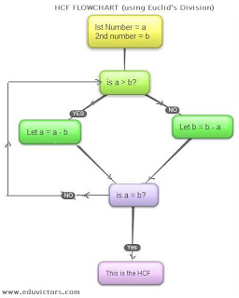

1. The algorithm is clear, simple and easy to follow.
2. It is short, and reader can easily follow this to get hcf.
3. Improvements: The arrow sign are missing or not clear somewhere, so putting those arrow sign in right direction and in a more visible way will help.